|  |  |
| --- | --- |
| as-map | **AUSTRALIA** |

**General**

|  |  |  |  |
| --- | --- | --- | --- |
| Area: | 7,686,850 km2 | Population: | 20,264,082 |
|  |  | Urban: | 79% |
|  |  | Rural: | 21% |
| Main Language: | English | Growth Rate: | 0.85% per year |

**Water Resources**

|  |  |  |  |
| --- | --- | --- | --- |
| Rainfall: | 1650 mm |  | |
|  |  |  | |
| Total water withdrawals: | 24km3/year | Domestic: | % 18 |
| Industrial: | % 10 |
| Agricultural: | % 72 |

**Health**

|  |  |
| --- | --- |
| Life expectancy: | 80.5 years |
| Infant mortality rate: | 4.63 infant deaths /1000 live births |

**Literacy**

|  |  |
| --- | --- |
| Area literacy: | >99% population age 15 and above. |
|  |  |

**Economy**

|  |  |
| --- | --- |
| GDP per capita (PPP US$): | $31,900 |

### **Instructions – Australia**

1. Loosely put a cotton plug in the neck of the cut bottle, then cover the neck of the bottle with a piece of cheese cloth secured with a rubber band.

2. Pour a 1-cm layer of fine sand over the cotton plug, followed by activated charcoal, 1-cm of coarse sand, fine gravel, and coarse gravel. Clean the filter by slowly and carefully pouring through clean water (over a bucket).

3. Place the filter over the bottom part of the bottle. Now, test your water filter by pouring half of the dirty water through the filter.

4. After waiting until more than half of the water poured through the filter has been collected, add 2 tablespoons (30 ml) of bleach to the filtered water.

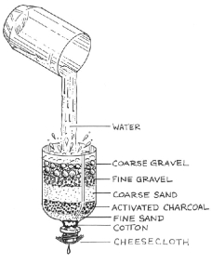

**Cost of Materials:**

|  |  |  |  |
| --- | --- | --- | --- |
| Activated Charcoal | $50/cup | Coarse Gravel | $10/cup |
| Cheesecloth | $5/square | Fine Gravel | $10/cup |
| Cotton | $5/ball | Coarse Sand | $20/cup |
| Rubber Band | $5 each | Fine Sand | $20/cup |

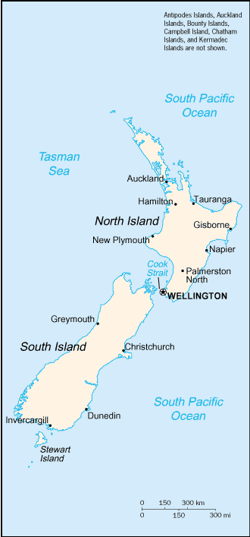**NEW ZEALAND**

**General**

|  |  |  |  |
| --- | --- | --- | --- |
| Area: | 268,680 km2 | Population: | 4,076,140 |
|  |  | Urban: | % |
|  |  | Rural: | % |
| Main Language: | English | Growth Rate: | 0.99% per year |

**Water Resources**

|  |  |  |  |
| --- | --- | --- | --- |
| Rainfall: | 100mm | Total water use |  |
|  |  | Domestic: | 18% |
|  |  | Industrial: | 10% |
| Total water withdrawals: | 2km3/year | Agricultural: | 72% |

**Health**

|  |  |
| --- | --- |
| Life expectancy: | 78.81 years |
| Infant mortality rate: | 5.76 infant deaths /1000 live births |

**Literacy**

|  |  |
| --- | --- |
| Area literacy: | >99% population age 15 and above. |

**Economy**

|  |  |
| --- | --- |
| GDP per capita (PPP US$): | $25,200 |

### **Instructions – New Zealand**

1. Loosely put a cotton plug in the neck of the cut bottle, then cover the neck of the bottle with a piece of cheese cloth secured with a rubber band.

2. Pour a 1-cm layer of fine sand over the cotton plug, followed by activated charcoal, 1-cm of coarse sand, fine gravel, and coarse gravel. Clean the filter by slowly and carefully pouring through clean water (over a bucket).

3. Place the filter over the bottom part of the bottle. Now, test your water filter by pouring half of the dirty water through the filter.

4. After waiting until more than half of the water poured through the filter has been collected, add 2 tablespoons (30 ml) of bleach to the filtered water.



**Cost of Materials:**

|  |  |  |  |
| --- | --- | --- | --- |
| Activated Charcoal | $50/cup | Coarse Gravel | $10/cup |
| Cheesecloth | $5/square | Fine Gravel | $10/cup |
| Cotton | $5/ball | Coarse Sand | $20/cup |
| Rubber Band | $5 each | Fine Sand | $20/cup |

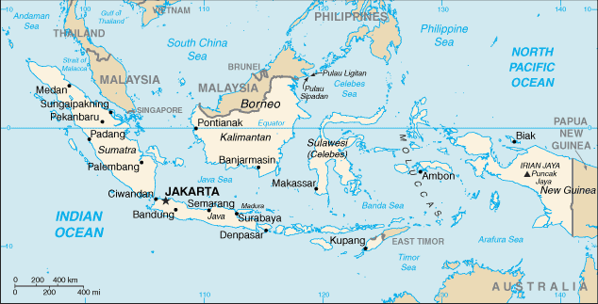

**INDONESIA**

|  |  |
| --- | --- |
|  |  |

**General**

|  |  |  |  |
| --- | --- | --- | --- |
| Area: | 1,919,440 km2 | Population: | 245,452,739 |
|  |  | Urban: | % |
|  |  | Rural: | % |
| Main Language: | Bahasa Indonesian | Growth Rate: | 1.41% per year |

**Water Resources**

|  |  |  |  |
| --- | --- | --- | --- |
| Rainfall: | 1500-4000mm | Total water use | |
| Total water withdrawals: | 83km3/year | Domestic: | 7% |
| Industrial: | 3% |
| Agricultural: | 90% |

**Health**

|  |  |
| --- | --- |
| Life expectancy: | 69.87 years |
| Infant mortality rate: | 34.39 infant deaths/ 1000 live births |

**Literacy**

|  |  |
| --- | --- |
| Area literacy: | 87.9% of population age 15 and above. |
|  |  |

**Economy**

|  |  |
| --- | --- |
| GDP per capita (PPP US$): | $ 3600 |

### **Instructions – Indonesia**

1. put a cotton  in the  of the cut bottle,  cover the neck of the  with a  of cheese  secured with a  band.

2. Pour a 1-cm  of fine sand  the cotton plug, followed by , 1-cm of  sand, fine , and  gravel.  the filter by  and carefully pouring through  water (over a ).

3. Place the  over the part of the bottle. □, test your  filter by  half of the dirty  through the filter.

4. After waiting  more than  the water  through the filter has been , add 2 tablespoons (30 ml) of  to the  water.

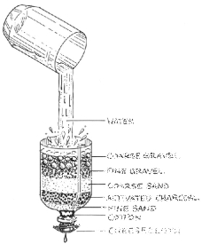

**Cost of Materials:**

|  |  |  |  |
| --- | --- | --- | --- |
| Activated Charcoal | $50/cup | Coarse Gravel | $10/cup |
| Cheesecloth | $1/square | Fine Gravel | $10/cup |
| Cotton | $1/ball | Coarse Sand | $10/cup |
| Rubber Band | $1 each | Fine Sand | $10/cup |

|  |  |
| --- | --- |
| in-map | **INDIA** |

**General**

|  |  |  |  |
| --- | --- | --- | --- |
| Area: | 3,287,590 km2 | Population: | 1,095,351,995 |
|  |  | Urban: | % |
|  |  | Rural: | % |
| Main Language: |  | Growth Rate: | 1.38% per year |

**Water Resources**

|  |  |  |  |
| --- | --- | --- | --- |
| Rainfall: | 500-10000mm | Total water use | |
| Total water withdrawals: | 83km3/year | Domestic: | 5% |
| Industrial: | 3% |
| Agricultural: | 92% |

**Health**

|  |  |
| --- | --- |
| Life expectancy: | 64.71 Years |
| Infant mortality rate: | 54.63 infant deaths/ 1000 live births |

**Literacy**

|  |  |
| --- | --- |
| Area literacy: | 59.5% of population age 15 and above. |
|  |  |

**Economy**

|  |  |
| --- | --- |
| GDP per capita (PPP US$): | $3,300 |

**Instructions – India**

1. Loosely put a  plug in the  of the cut , then  the  of the  with a  of cheese  secured  rubber .

2.  a 1-cm  of fine sand  the cotton plug,  by  charcoal, 1-cm of  sand, fine gravel,  gravel.  the filter by carefully pouring  clean water (bucket).

3. Place the over the  part of the bottle. Now,  your water filter by pouring  of the dirty water through the filter.

4. After waiting  more than half of the water  through the filter has been collected, add 2  (30 ml) of bleach to the filtered water.

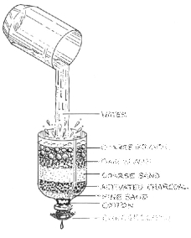

**Cost of Materials:**

|  |  |  |  |
| --- | --- | --- | --- |
| Activated Charcoal | $50/cup | Coarse Gravel | $10/cup |
| Cheesecloth | $1/square | Fine Gravel | $10/cup |
| Cotton | $1/ball | Coarse Sand | $10/cup |
| Rubber Band | $1 each | Fine Sand | $10/cup |

|  |  |
| --- | --- |
| vm-map | **VIETNAM** |

**General**

|  |  |  |  |
| --- | --- | --- | --- |
| Area: | 329,560 km2 | Population: | 84,402,966 |
|  |  | Urban: | % |
|  |  | Rural: | % |
| Main Language: | Vietnamese | Growth Rate: | 1.02% per year |

**Water Resources**

|  |  |  |  |
| --- | --- | --- | --- |
| Rainfall: | 1000mm | Total water use | |
| Total water withdrawals: | 71km3/year | Domestic: | 4% |
| Industrial: | 8% |
| Agricultural: | 82.1% |

**Health**

|  |  |
| --- | --- |
| Life expectancy: | 70.85 years |
| Infant mortality rate: | 25.14 infant deaths/ 1000 live births |

**Literacy**

|  |  |
| --- | --- |
| Area literacy: | 90.3% of population age 15 and above. |
|  |  |

**Economy**

|  |  |
| --- | --- |
| GDP per capita (PPP US$): | $ 2,800 |

### 

### **Instructions – Vietnam**

1.  put a cotton  neck of the cut , then  neck of the  a piece of cheese  with a rubber band.

2. Pour a 1 of fine sand over the  plug,  activated , 1-cm of , fine gravel, and coarse . Clean  filter  and carefully  clean water (over a bucket).

3.  filter over the  part of the bottle. □, test  water filter by pouring of the dirty  through the filter.

4. After  than half □ the  poured through the filter  been , add 2 tablespoons (30 ml) of bleach  water.

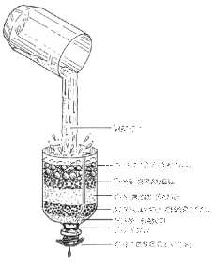

**Cost of Materials:**

|  |  |  |  |
| --- | --- | --- | --- |
| Activated Charcoal | $50/cup | Coarse Gravel | $10/cup |
| Cheesecloth | $1/square | Fine Gravel | $10/cup |
| Cotton | $1/ball | Coarse Sand | $10/cup |
| Rubber Band | $1 each | Fine Sand | $10/cup |

|  |  |
| --- | --- |
| et-map | **ETHIOPIA** |

**General**

|  |  |  |  |
| --- | --- | --- | --- |
| Area: | 1,127,127 km2 | Population: | 74,777,981 |
|  |  | Urban: | % |
|  |  | Rural: | % |
| Main Language: | Amharic, English | Growth Rate: | 2.31% per year |

**Water Resources**

|  |  |  |  |
| --- | --- | --- | --- |
| Rainfall: | 1000mm | Total water use | |
| Total water withdrawals: | 5km3/year | Domestic: | 11% |
| Industrial: | 1% |
| Agricultural: | 88% |

**Health**

|  |  |
| --- | --- |
| Life expectancy: | 49.03 years |
| Infant mortality rate | 93.62 infant deaths/ 1000 live births |

**Literacy**

|  |  |
| --- | --- |
| Area literacy: | 42.7% of population age 15 and above. |
|  |  |

**Economy**

|  |  |
| --- | --- |
| GDP per capita ($1881) | $900 |

**Instructions – Ethiopia**

1. Loosely  in the cut ,  cover  with  cloth 

2.  a -cm   cotton , followed  charcoal,  □ coarse  gravel,  Clean  by  pouring  clean  (over  bucket).

3. Place  over the  bottle. □, test  water  by pouring  dirty  the filter.

4.  until  half □  water  through  has been , add 2  (30 ) of  to  filtered .

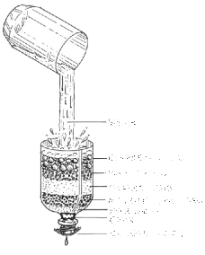

**Cost of Materials:**

|  |  |  |  |
| --- | --- | --- | --- |
| Activated Charcoal | $50/cup | Coarse Gravel | $10/cup |
| Cheesecloth | $1/square | Fine Gravel | $10/cup |
| Cotton | $1/ball | Coarse Sand | $10/cup |
| Rubber Band | $1 each | Fine Sand | $10/cup |